1. Set up the environment. Please use below portal for reference.

<http://docs.automation.applause.com/#developer-quick-start-guide>

1. Configure appium server with details of app. The app is located in root folder of the project. More info about configuring appium server also can be found in above portal.

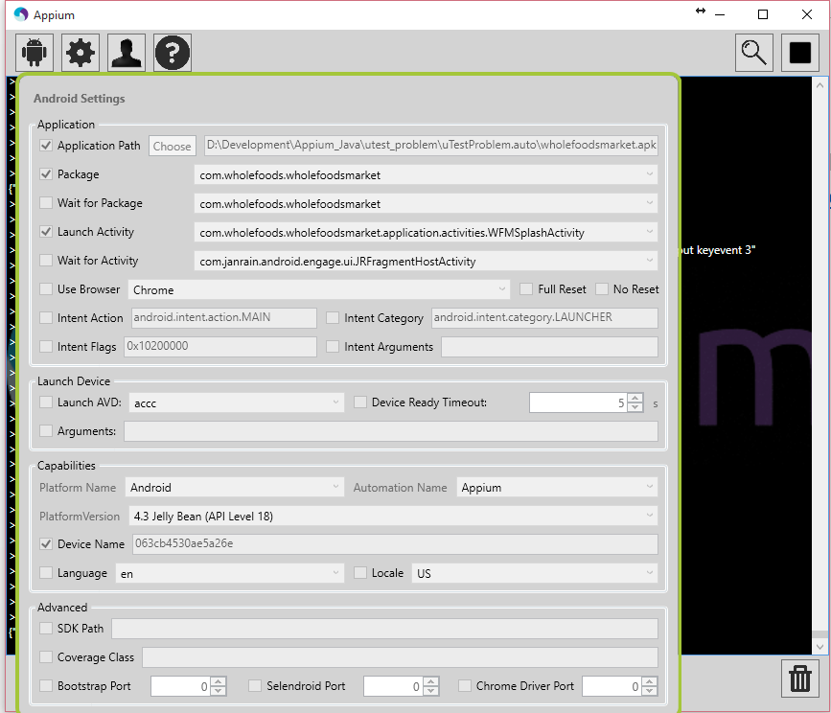

1. Prepare an emulator or any android device with android L version. The Debug mode should be enabled on the device. I have tested this test solution on following device: Nexus 5/5.1.1.
2. Install the app into device/emulator. The test solution do not ensure if the app is installed or not. This was not in task, and it would require additional time for solving.
3. If screen device is locked, then better to unlock it. And finally run run.bat’, also located in same root folder.